30

**Name (*Last, First*): Carganico Mattia, ID: 301278358.**

**Name (*Last, First*): _____________________________, ID: ______________.**

**For full marks, please provide complete solutions** in the space provided for each question. Late assignments will not be accepted.

1. For the following system of linear equations:

$$x+2y+5z=-11 \\ y-6z=19 \\ x-y+2z=-5$$

1. Find $A^{-1}$ using elementary row operations [5 marks]
2. Use $X=A^{-1}B$ to solve the above system of equation. [2 marks]

2. Solve using Cramer’s rule. A*ny other method of solving will not be awarded any marks*: [5.5 marks]

$$7x+4y-z=1 \\ 3x+y-2z=9 \\ x-5y-z=-7$$

1. For the following system of linear equations:

$$x-2y+z=17 \\ x-4z=-28 \\ y+3z=27$$

1. Find $A^{-1}$ using adjoint theorem [6.5 marks]

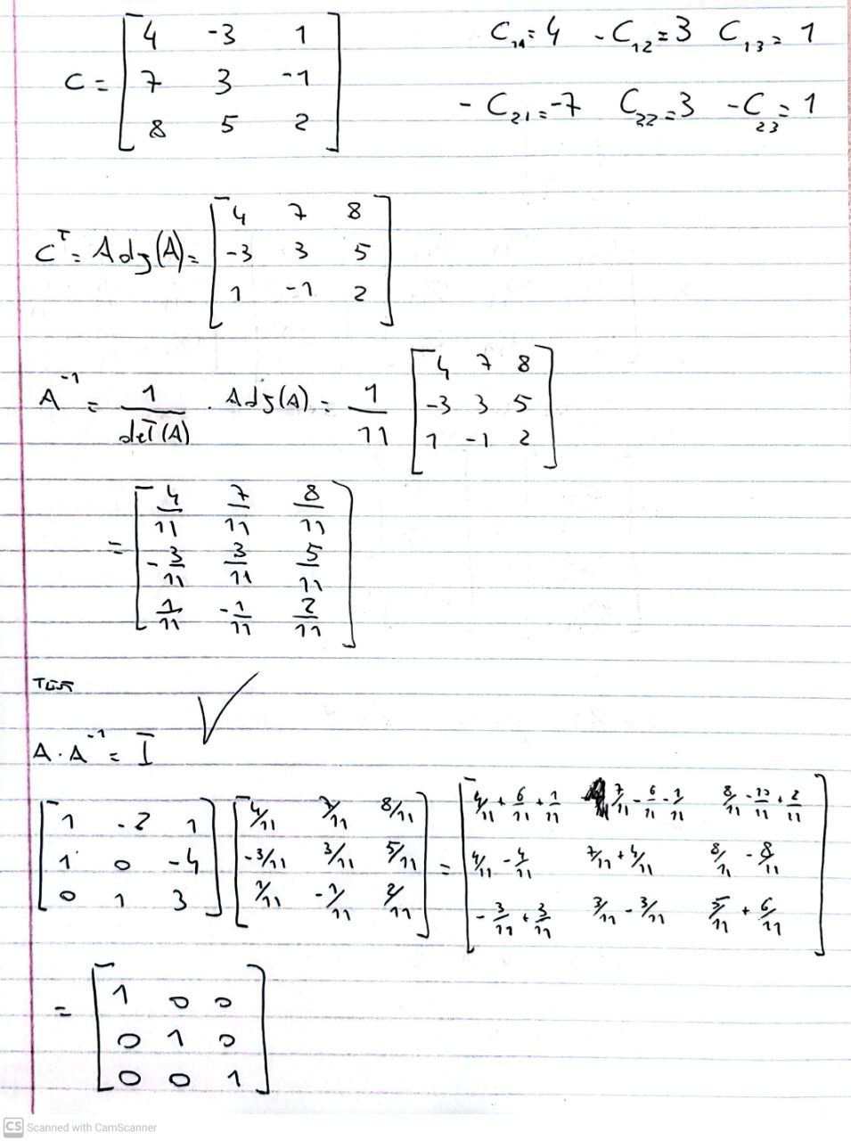

1. Use to solve the above system of equation. [2 marks]

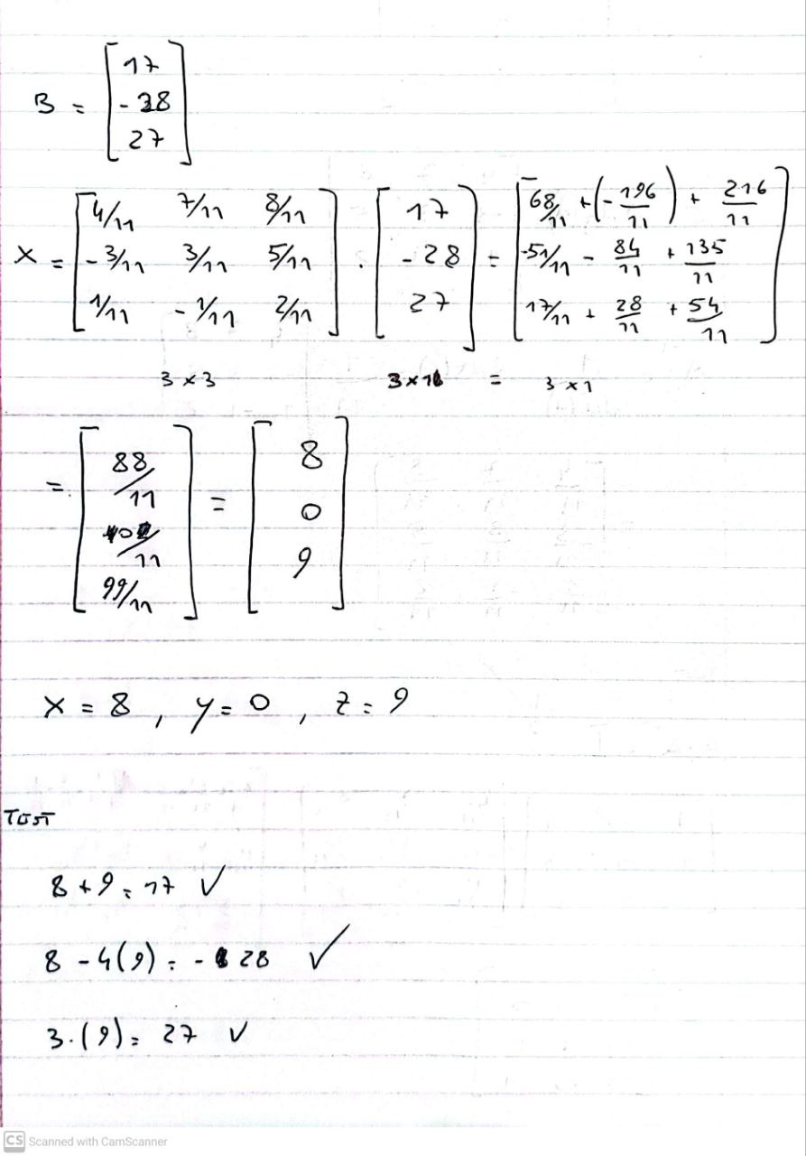

1. Find $det\left(-2A\right)$ if A is a **3 x 3** matrix and determinant of A is $det\left(A\right) =$ *5.* [2 marks]

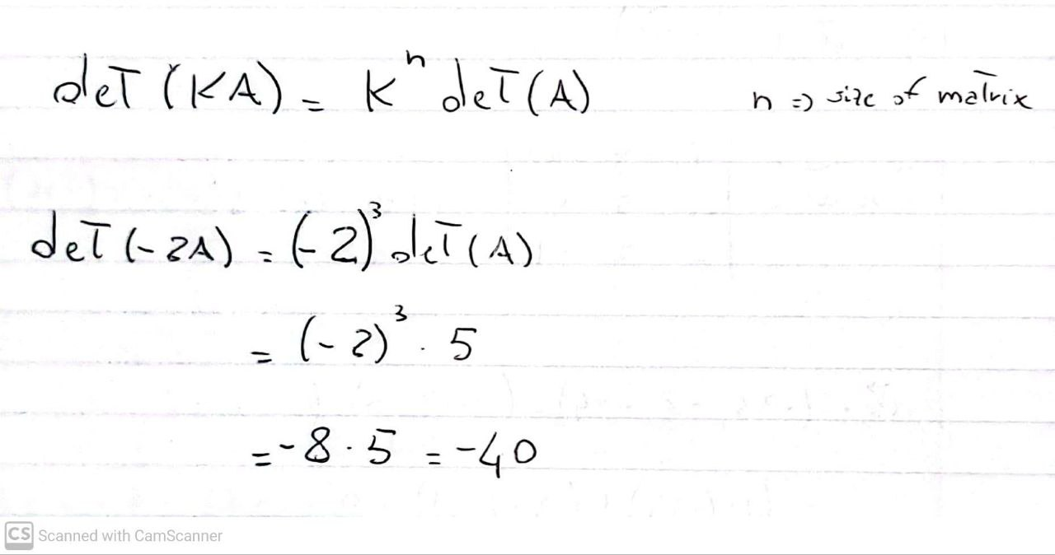

1. Given the matrix below, find ***c***so that the matrix is not invertible. [3 marks] $A= \left[\begin{matrix}1 & 0 & 7 \\ c & 2 & -3 \\ 6 & -1 & 2c\end{matrix}\right]$
2. a) Simplify the expression below by using the algebraic properties of matrices. Show your work. [3 marks]

$A {\left(B^{-1}A\right)}^{-1}B^{-1} D(CD)^{T}{\left(C^{T}\right)}^{-1}$

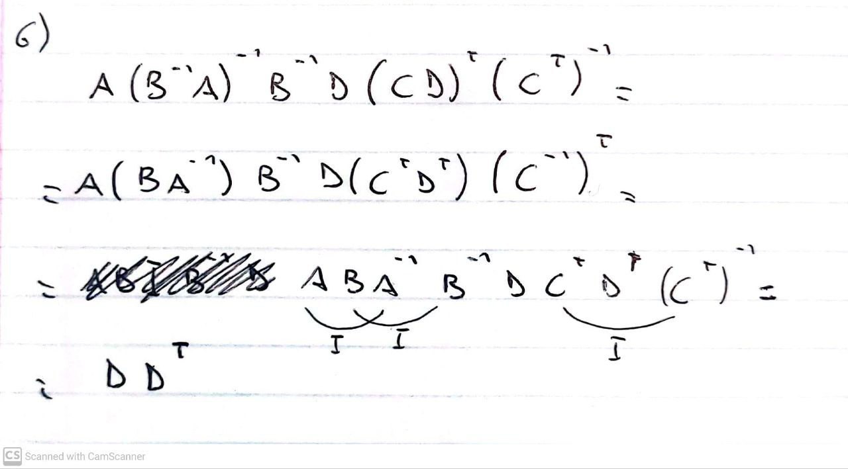

b) What special matrix is represented by the above simplified expression? [1 mark]

